Parent Name _______________________ | Student/Grade __________________________/_____
Phone _________________________ | Student/Grade __________________________/_____
Teacher Name _____________________ | Student/Grade __________________________/_____
 | Student/Grade __________________________/_____

Shirts are black with white/blue print | 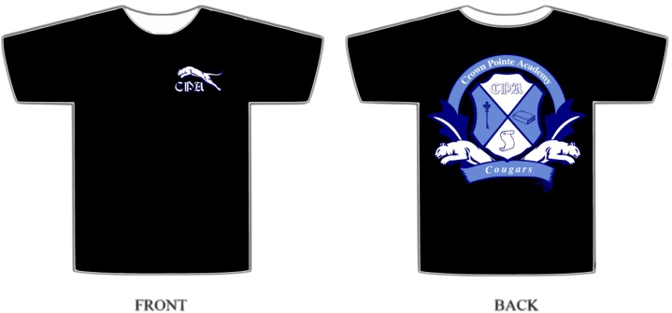

Orders are due on Friday, September 12, 2014. Expected delivery will be the week of September 29, 2014. There will only be one order placed for this T-shirt. This T-shirt may be worn in conjunction with Jeans Day every Friday.

Please indicate quantities for each size you are ordering and amount you are paying. Checks can be made payable to CPA-PTA. Please Return Order Forms to CPA, via Sandi MacGregor.

Size |  | Cost | Quantity | Total |  | Size |  | Cost | Quantity | Total
Youth | S (6-8) | $10 |  |  |  | Adult | 2XL | $15
 | M (10-12) | $10 |  |  |  |  | 3XL | $15
 | L (14-16) | $10 |  |  |  |  | 4XL | $15
Adult | S | $12 |  |  |  |  |  | Subtotal
 | M | $12
 | L | $12
 | XL | $12
 |  | Subtotal |  |  |  | GRAND TOTAL = |  |  | $__________

For PTA Use Only

Receipt for (Name) ____________________________________ | Total amount paid $___________

T-shirt(s)  ordered | Youth | S (6-8) _____ |  | M (10-12) _____ |  | L (14-16) _____
 | Adult | S _____ | M _____ | L _____ | XL _____ | 2XL ____ | 3XL ____ | 4XL ____

